FINAL REPORT - Battle of Neighborhoods:

# Introduction / Business Problem:

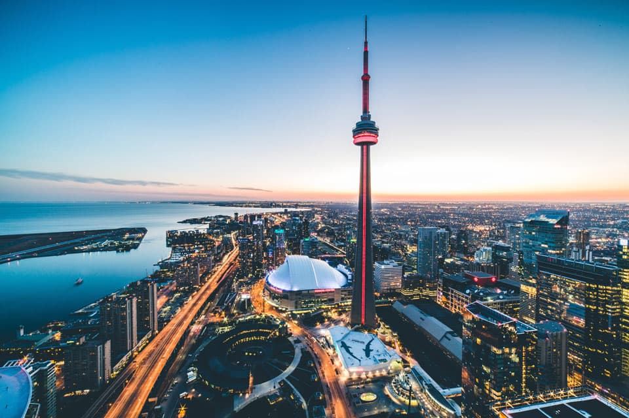

Toronto is the provincial capital of Ontario and the most populous city in Canada, with a population of 2,731,571 in 2016. People are always about their health and fitness and in recent time, more people use physical training center. Even though there are more training centers than historical days, still the most of them are crowded. In this project we will explore the neighborhoods of Toronto, perform analysis and recommend a best neighborhood to start a new **physical training center**.